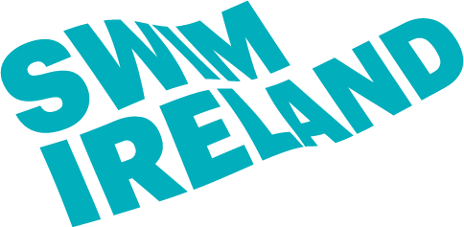
2023 Irish Open Diving Championships
Final Entry Form
Please send this entry form to divingentries@swimireland.ie
by Monday 23rd October 2023
NAME OF CLUB or NATIONAL FEDERATION
NAME OF LEAD CONTACT

LEAD CONTACT EMAIL

LEAD CONTACT MOBILE

NAME OF COACH / COACHES
NAME OF JUDGE / JUDGES

For Age Group and Junior/Senior Open event, one diver who enters for three individual boards will equal three entries
Cost per entry is €15 or £13

LEVEL OF EVENT | TOTAL NUMBER  OF ENTRIES | TOTAL  COST
JUNIOR/SENIOR OPEN EVENT

AGE GROUP EVENT

NOVICE EVENT

TOTAL COST

Enter the names of the divers using the sheets below
JUNIOR / SENIOR OPEN EVENT
FIRST NAME | LAST NAME | Date  Of  Birth | Junior or Senior  (J or S) | Male Female | Governing body registration no. | 1M | 3M | Plt

AGE GROUP EVENT
FIRST NAME | LAST NAME | Date  Of  Birth | Age Group  (C,B,A) | Male Female | Governing body registration no. | 1M | 3M | Plt

NOVICE EVENT
FIRST NAME | LAST NAME | Date  Of  Birth | Male Female | Governing body registration no. | GROUP E | GROUP D | GROUP C | GROUP B+

