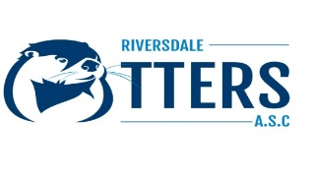
Riversdale Otters ASC is based in Riversdale Leisure Centre, Strabane and we are seeking experienced Level 2 Teachers and a Level 2 Coach to join our coaching team. We are affiliated with Swim Ireland; Swim Ulster and our Club has in the region of one hundred and thirty members.
Key responsibilities of the role include:
- Working alongside our existing team of dedicated Swim Coaches and Teachers to deliver:
  - Effective coaching sessions.
  - Individual swimmer feedback and target-setting.
  - Continual monitoring of swimmer’s development.
- Assistance in the squad selection and attendance at competitions/galas.
- Working closely with CCO to prioritise swimmer welfare and compliance with Swim Ireland procedures.
Requirements and Skills
Essential:
- Demonstrable experience in delivering effective swim coaching.
- Proven track record of developing age group swimmers to competition standard.
- Excellent interpersonal and motivational skills
- Swim Ireland Level 2 Teacher Certificate, Swim Ireland Level 2 Coaching Certificate.
- Candidates must complete Swim Ireland Safeguarding and Access NI application. (This can be organised for the successful candidates).
How to apply: Please send your CV and qualifications to riversdaleotters@gmail.com

